**Painting Mistake**

There has been a huge manufacturing error at a checkerboard factory! They’ve accidentally painted the cells the wrong color and need your help correcting it. The way it works is that in order to fix the painting error, you will be able to swap any two rows or any two columns with each other. Do you think you can find the minimum number of swaps required to correctly paint the board?

**Input:** The first line of input contains **T**, the number of test cases. The first line of each test case contains **N** the rows and columns of each board. The next **N** lines contain **N** space-separated integers which will be either a 1 or a 0.

**Output:** You will first “CASE #(case number): “ followed by the minimum number of flips required to correctly paint the board. If it can’t be fixed you will output -1.

**Example Input:**

3

4

0 1 1 0

0 1 1 0

1 0 0 1

1 0 0 1

2

0 1

1 0

2

1 0

1 0

**Example Output:**

CASE #1: 2

CASE #2: 0

CASE #3: -1

**Explanation:** For the first test case, a possible solution sequence is pictured below:

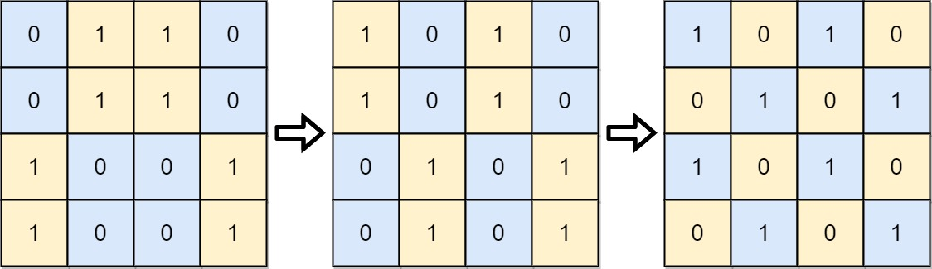

For the second test case, it is already in the correct pattern as shown below:

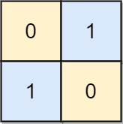

For the third test case, there is no possible solution, so we return -1:

